**Homework 4 Instructions**

Create 5 plots using the Tableau Packaged Workbook template. It already has the data set loaded so you don’t have to do anything about that. The dashboard to recreate is hosted on Tableau Public:

[https://public.tableau.com/profile/ashwin.malshe1136#!/vizhome/Homewohttps://www.linkedin.com/in/rudy-ja-martinez/rk4_16055661240890/MapofRiskyRestaurants](https://public.tableau.com/profile/ashwin.malshe1136#!/vizhome/Homework4_16055661240890/MapofRiskyRestaurants)

You **don’t** have to match the colors, theme, etc. Just make sure that you get similar functionality and the numbers are the same. For example, your map may look different that mine because you used a different base layer.

The data set is obtained from here:

<https://www.kaggle.com/san-francisco/sf-restaurant-scores-lives-standard/downloads/sf-restaurant-scores-lives-standard.zip/3>

I have made some minor changes to the data set. For location, I have added longitude and latitude variables but note that Tableau has also generated them automatically using the business zip code. I have created the map using *averages* of *my* geo coordinates.

**How to submit?**

Once you complete your homework, upload it to Tableau Public and publish it. Make sure that everything works fine. Next, copy the URL of the workbook and paste it in a Word document. Make sure that you write your name in the Word document. Submit that Word document on Blackboard. You don’t need to submit the Tableau Workbook.

Note that you are using a Tableau Pro version currently so you will have to create a separate free account for Tableau Public. Then follow these instructions: <https://help.tableau.com/current/pro/desktop/en-us/publish_workbooks_tableaupublic.htm>

**Important:** Before Tableau uploads your workbook, it will ask you to create a data extract. Make sure that your data connection in the “Data” window is set to “Extract” and not to “Live”. If you get an error message like this – “Data Extract Required”, follow the instructions here:

<https://kb.tableau.com/articles/issue/error-data-extract-required-saving-workbok-to-tableau-public>

Finally, ***after*** you publish the workbook on Tableau, you can edit the settings. The settings will show up at the bottom of the workbook. You can provide your name in the title such as “Homework 4 submission by [XYZ]” where XYZ is your name. Also, make sure that the last checkbox at the bottom against “Show workbook sheets as tabs” is checked. I show the screenshot of these settings on the next page. Also I made a short video explaining this:

<https://youtu.be/v1HePDtv5l4>

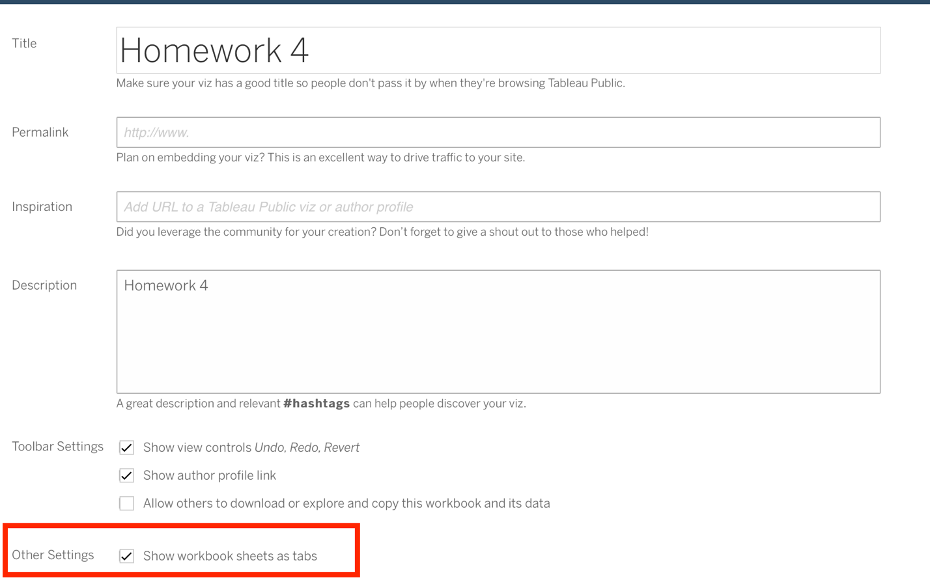

**The description of the data from Kaggle:**

**Content**

The Health Department has developed an inspection report and scoring system. After conducting an inspection of the facility, the Health Inspector calculates a score based on the violations observed. Violations can fall into: high risk category: records specific violations that directly relate to the transmission of food borne illnesses, the adulteration of food products and the contamination of food-contact surfaces. moderate risk category: records specific violations that are of a moderate risk to the public health and safety. low risk category: records violations that are low risk or have no immediate risk to the public health and safety. The score card that will be issued by the inspector is maintained at the food establishment and is available to the public in this dataset. San Francisco's LIVES restaurant inspection data leverages the LIVES Flattened Schema (<https://goo.gl/c3nNvr>), which is based on LIVES version 2.0, cited on Yelp's website (<http://www.yelp.com/healthscores>).

**Context**

This is a dataset hosted by the city of San Francisco. The organization has an open data platform found [here](https://data.sfgov.org) and they update their information according the amount of data that is brought in. Explore San Francisco's Data using Kaggle and all of the data sources available through the San Francisco [organization page](https://www.kaggle.com/san-francisco)!

* Update Frequency: This dataset is updated daily.